**Lesson 3 Demo 11**

**Backing up and Restoring Etcd Cluster Data**



Steps to be followed:

1. Backing up etcd cluster data
2. Retrieving etcd cluster data

**Step 1: Backing up etcd cluster data**

1. Use the following command to install **etcd-client:**

***sudo apt install etcd-client***

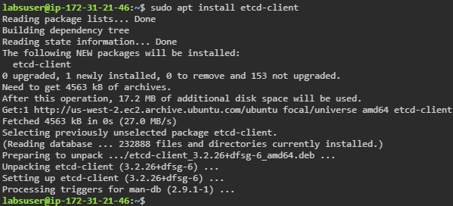

1. List all the pods of **kube-system** namespace

***kubectl get pods -n kube-system***

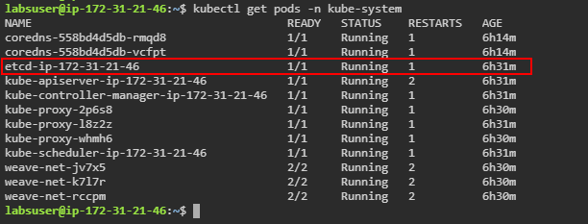

1. Describe the **etcd** pod of **kube-system** namespace and copy the ip-address of the **--advertise-client-url** flag:

***kubectl describe pods <etcd-pod-name> -n kube-system***

| **Note:** Replace **<<etcd-pod-name>>** with the name of your etcd pod. |
| --- |

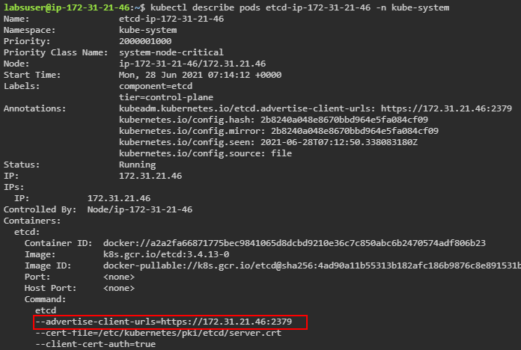

1. Export the **advertise-client-url**to **advertise_url**

***export advertise_url=<<advertise-client-url>>***

***echo $advertise_url***

| **Note:** Replace **<<advertise-client-url>>** with the advertise-client-url copied from **Step 1.3** |
| --- |



1. Use the following command to save **etcd** backup:

***sudo ETCDCTL_API=3 etcdctl \***

***--endpoints $advertise_url \***

***--cacert /etc/kubernetes/pki/etcd/ca.crt \***

***--key /etc/kubernetes/pki/etcd/server.key \***

***--cert /etc/kubernetes/pki/etcd/server.crt snapshot save etcd_backup.db***

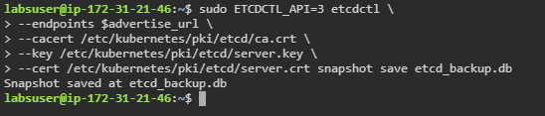

1. Use the following command to check the newly created **etcd_backup.db** file:

***ls***

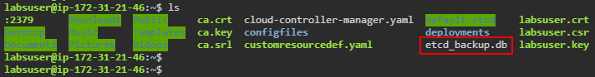

**Step 2: Retrieving etcd cluster data**

1. Type the following command to restore etcd cluster data:

***sudo ETCDCTL_API=3 etcdctl \***

***--endpoints $advertise_url \***

***--cacert /etc/kubernetes/pki/etcd/ca.crt \***

***--key /etc/kubernetes/pki/etcd/server.key \***

***--cert /etc/kubernetes/pki/etcd/server.crt snapshot restore etcd_backup.db***

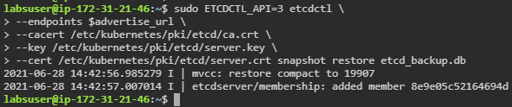

1. Set the ownership on the new data directory

***sudo chown -R etcd:etcd /var/lib/etcd***

1. Verify the cluster

***sudo ETCDCTL_API=3 etcdctl get cluster.name \***

***--endpoints $advertise_url \***

***--cacert /etc/kubernetes/pki/etcd/ca.crt \***

***--key /etc/kubernetes/pki/etcd/server.key \***

***--cert /etc/kubernetes/pki/etcd/server.crt***